# Mail - Gary Atlin - 8 May

Hi Hans-Peter,

I was really struck by the size of the GxL variance for Boro. I was not expecting this. Can we look at the correlations of genotypic effects (or means) among sites? I am still resisting the idea that there is specific adaptation to favorable boro sites in Bangladesh, but we need to check.

Best,

Gary

# Approach

The genetic correlation is related to effects gen and gen:loc. Under a simple variance-components model, all environments have the same "genetic" variance, i.e. var(gen) + var(gen:loc), and the same covariance, i.e. var(gen). This amounts to the compound symmetry structure, which has genetic correlation of var(gen) ( [ var(gen) + var(gen:loc) ] for all pairs of locations.

This can be generalized and made more flexible. The most complex model is to drop the genotype main effect and fit an unstructured model. This can be achieved in ASREML via *us(loc):gen*.

Alternatively, we can use an FA model instead, making a choice regarding the number of multiplicative terms, e.g. three:  *fa(loc,3):gen*

From these fits, we should be able to extract the ***10 x 10 genetic correlation matrix between locations***. If the US model works, it's simplest to just use that.

# Results

In order to examine the issue at hand, we look at the size for the GxL variances from the model

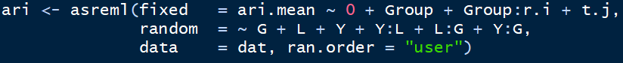

|  |  |  |  |  |  |
| --- | --- | --- | --- | --- | --- |
|  | Aman |  |  | Boro |  |
| CovParm | estimate | std.error | CovParm | estimate | std.error |
| G | 0,136 | 0,050 | G | 0,066 | 0,023 |
| L | 0,214 | 0,131 | L | 0,496 | 0,257 |
| Y | 0,039 | 0,044 | Y | 0,089 | 0,064 |
| Y:L | 0,508 | 0,077 | Y:L | 0,610 | 0,083 |
| L:G | 0,062 | 0,010 | L:G | 0,063 | 0,009 |
| Y:G | 0,025 | 0,006 | Y:G | 0,008 | 0,004 |
| R | 0,331 | 0,011 | R | 0,343 | 0,010 |

We can estimate the genetic correlation between locations as var(G)/[var(G)+var(L:G)]. Furthermore, we can plot the variance components as bar graphs:

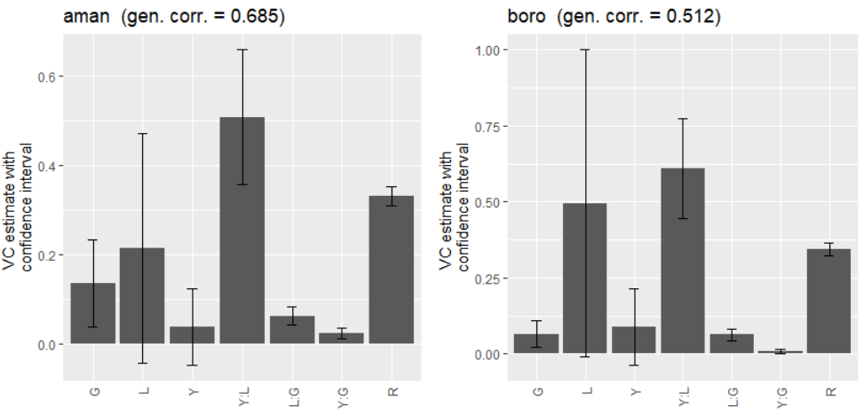

Based on our experiences we would not say that the G:L variance component is large. In my eyes, it is relatively small or at least displays a reasonable size.

We tried fitting models with *us(L):G* and *fa(L):G* but almost none of them converged:

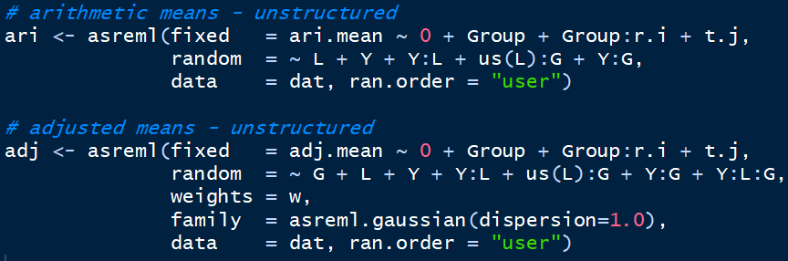

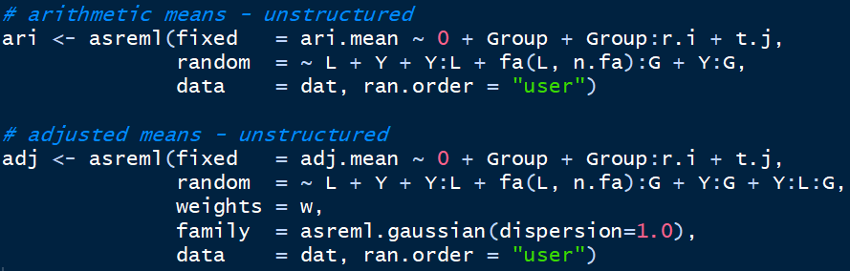

The reason for the convergence problems might in fact be that the L:G variance component is so small.